ABC’s Inventory Management System

Manage Product (Update Product) Test Scripts

Table of Contents

UPT001- Update different data of a product that already exists by entering accurate values 3

Data Set 1 3

Result Screenshots: 4

Data Set 2 6

Result Screenshots: 7

UPT002- Skipping few data while updating details of a product that already exists 10

Data Set 1 10

Result Screenshots: 10

Data Set 2 14

Result Screenshots: 14

UPT003- Entering invalid Price value while updating a Product 17

Data Set 1 17

Result Screenshots: 17

Data Set 2 20

Result Screenshots: 20

# UPT001- Update different data of a product that already exists by entering accurate values

|  |  |  |  |  |  |
| --- | --- | --- | --- | --- | --- |
| **Test Name** | | Test update different data of a product that already exists by entering accurate values (Test UPT001) | | | |
| **Use Case Tested** | | Manage Product | | | |
| **Test Description** | | This test tests if the system can update different values of a product when accurate data is entered. | | | |
| **Pre-Conditions** | | Users need be logged in as a Warehouse Staff (Warehouse Staff Access) in the Manage Product page  Meta data to store Product details in the database must exist. | | | |
| **Post-Conditions** | | Product details are updated. | | | |
| **Result (Pass/Fail/Warning/ Incomplete)** | | Pass | | | |
|  | **Test Step** | | **Expected Test Results** | **P** | **F** |
| 1. | Click on ‘Edit’ icon for the product whose details must be changed at the ‘Manage Product’ page. | | Update Product Page is displayed with all the details which are editable except for the product code. | P |  |
| 2. | Change required values. | | System waits for the user to click on the ‘Confirm’ icon. | P |  |
| 3. | Click on the ‘Confirm’ icon. | | System updates the product details and system displays an appropriate message. | P |  |
| 4. |  | | Manage Product Page is displayed. | P |  |

## Data Set 1

|  |  |
| --- | --- |
| **Data Set 1** | |
| **Fields** | **Values** |
| **Product Code** | L2 |
| **Product Name** | Test Product |
| **Price** | 89.00 |
| **Description** | This is a Test Product |

### Result Screenshots:

**Step 1**

Click on ‘Edit’ icon for the product L2 at ‘Manage Product’ Page

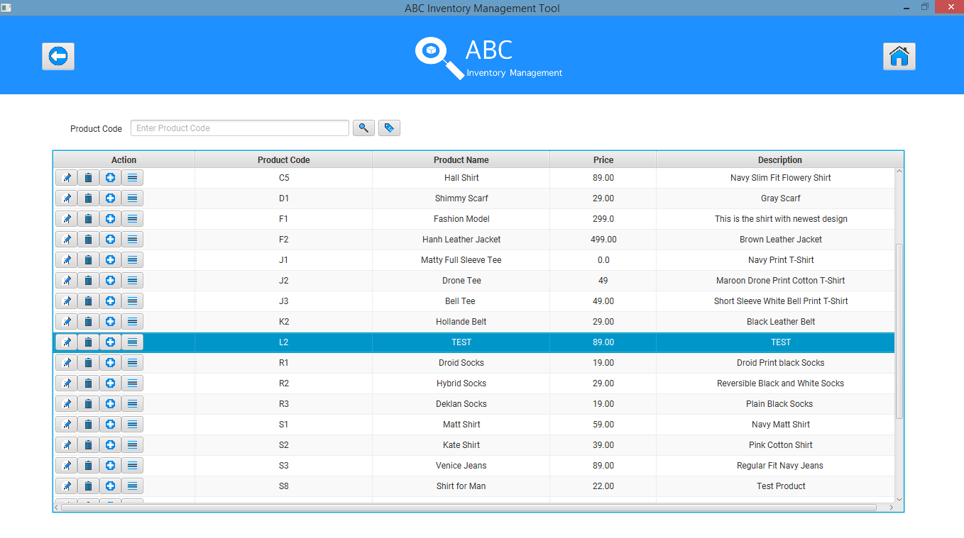

System displays the current details of the product selected which can be edited except for the product code.

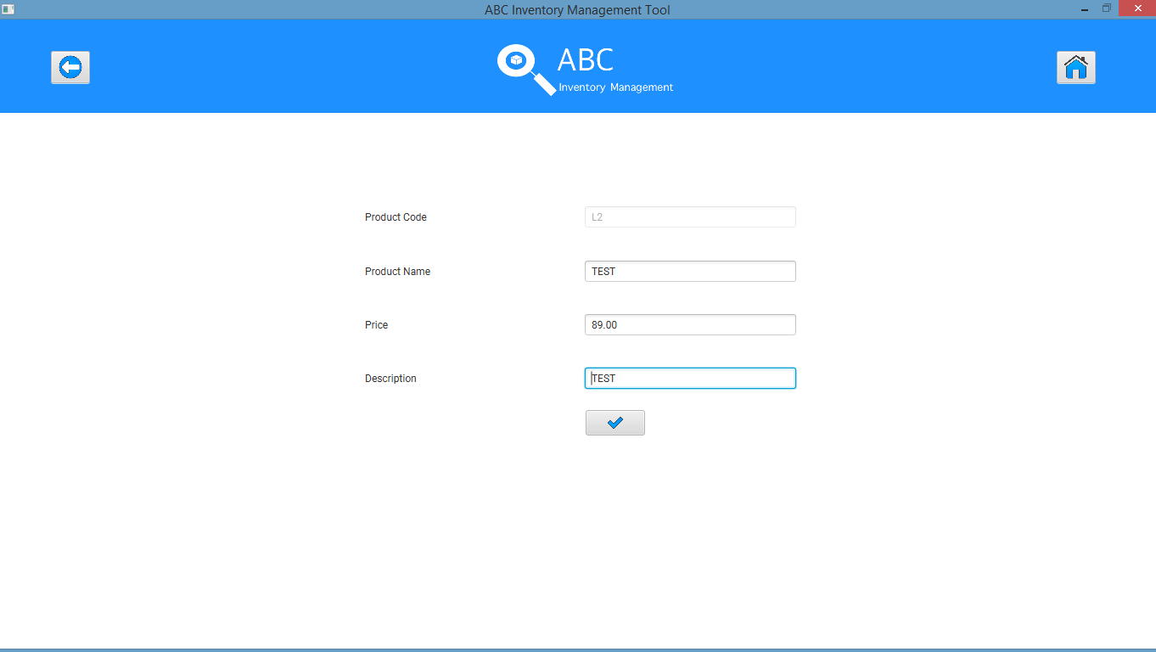

**Step 2**

Change the required values.

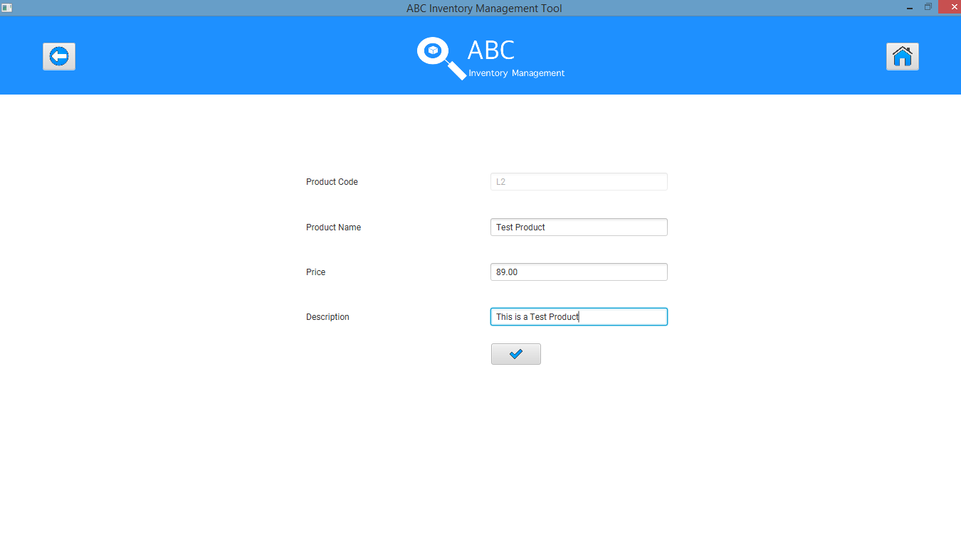

**Step 3**

After clicking on the ‘Update’ icon.

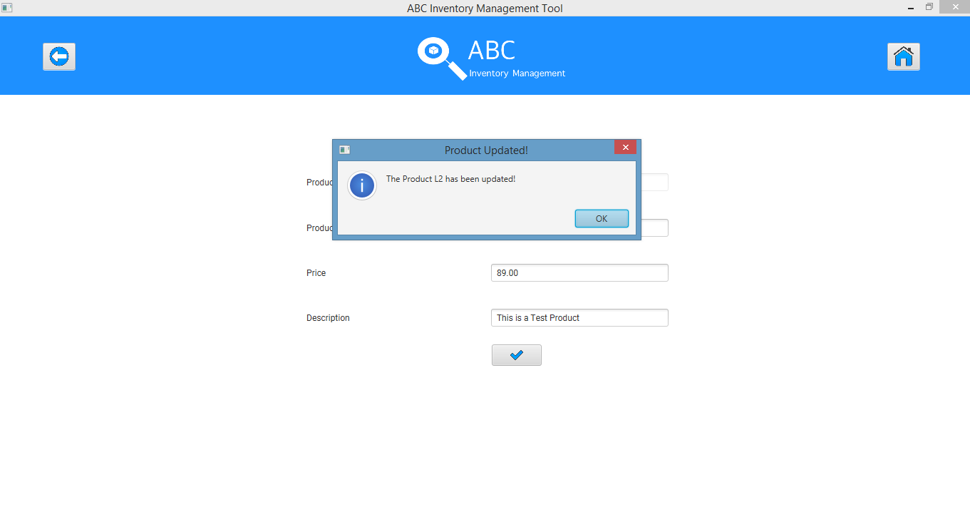

**Step 4**

System displays the ‘Manage Product’ page after the user clicks on ‘Ok’ in the dialog box.

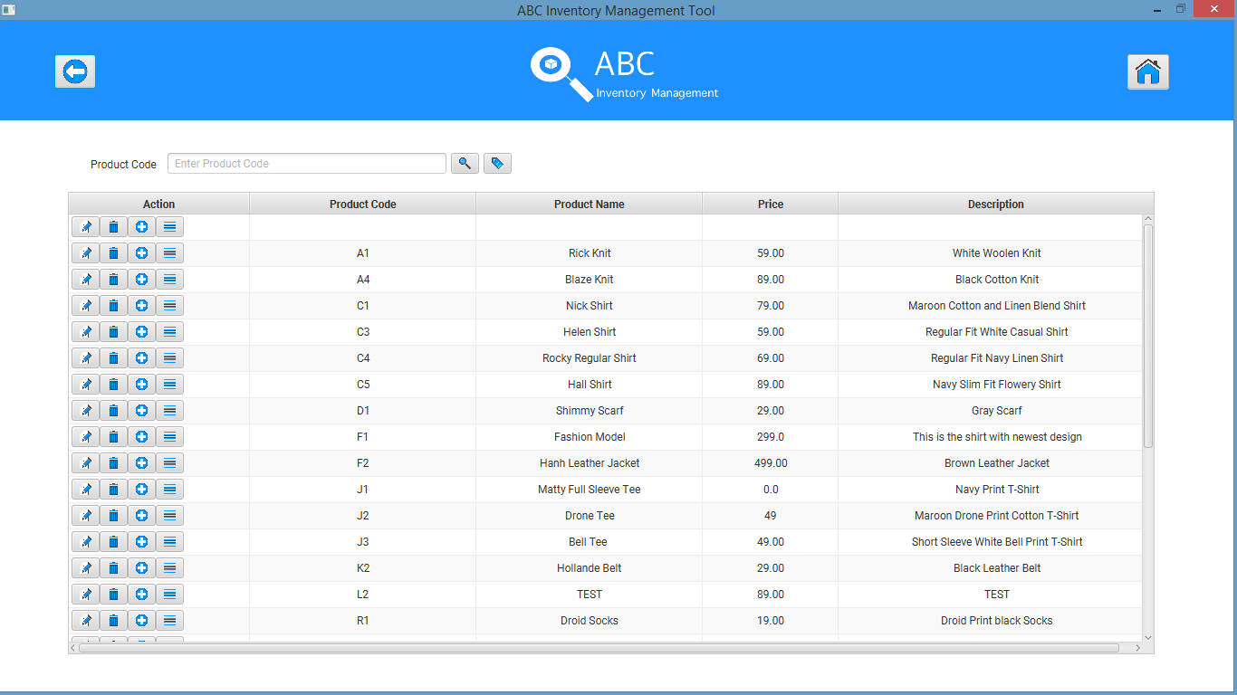

## Data Set 2

|  |  |
| --- | --- |
| **Data Set 2** | |
| **Fields** | **Values** |
| **Product Code** | S1 |
| **Product Name** | Grant Shirt |
| **Price** | 89.00 |
| **Description** | Navy Slim Cotton Shirt |

### Result Screenshots:

**Step 1**

Click on ‘Edit’ icon for the product S1 at ‘Manage Product’ Page

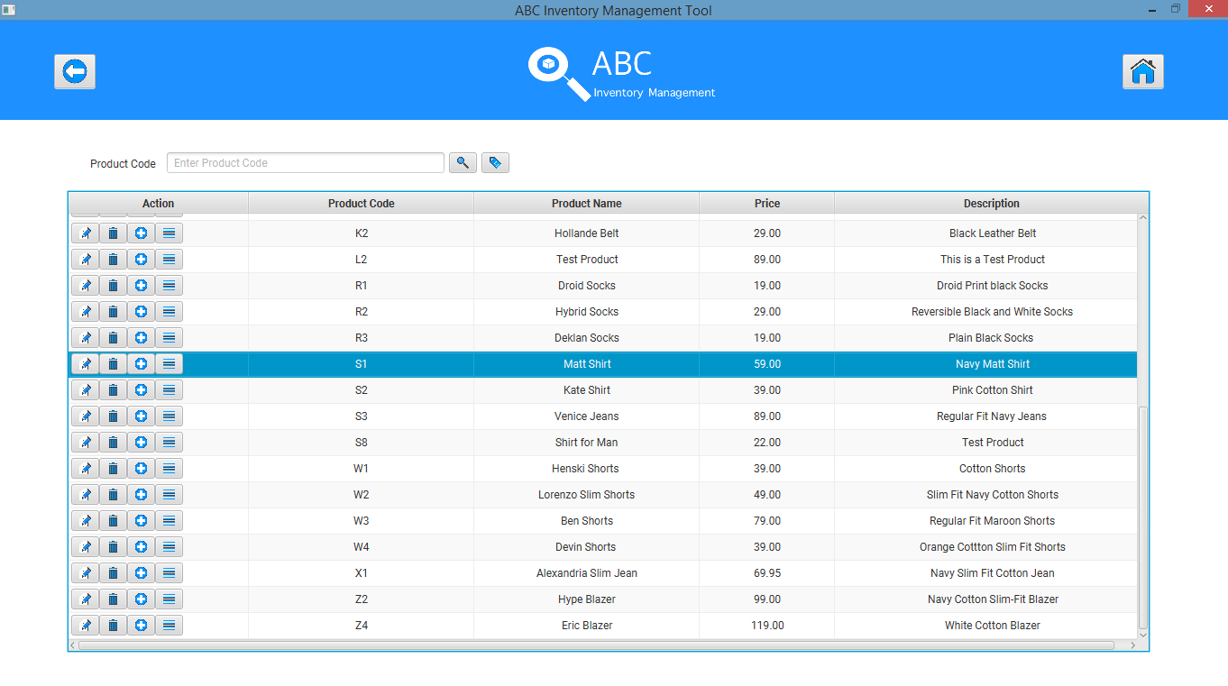

System displays the current details of the product selected which can be edited except for the product code.

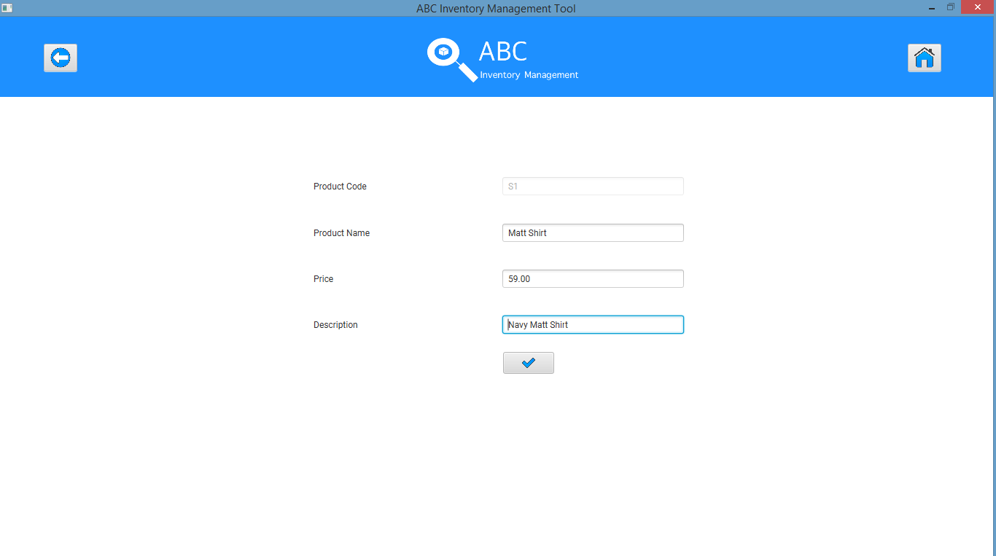

**Step 2**

Change the required values.

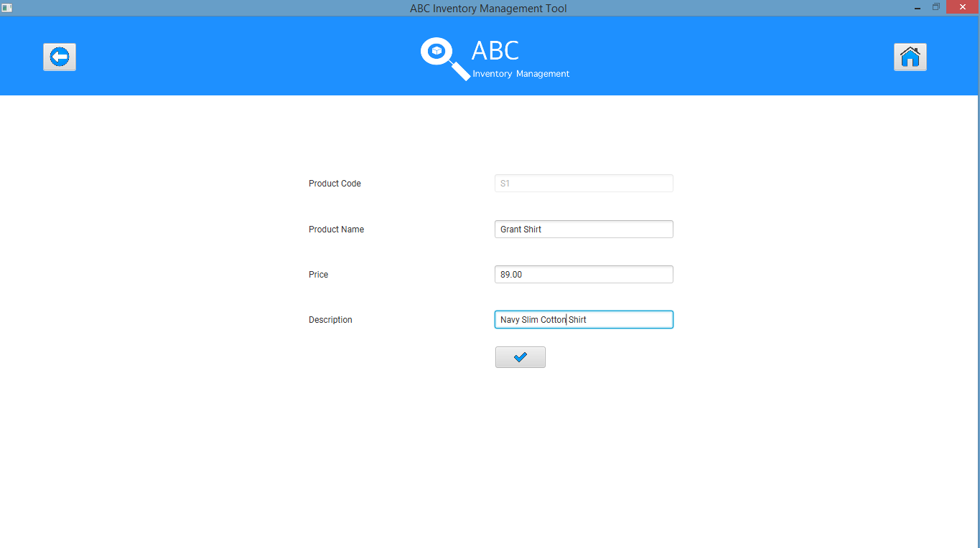

**Step 3**

After clicking on the ‘Update’ icon.

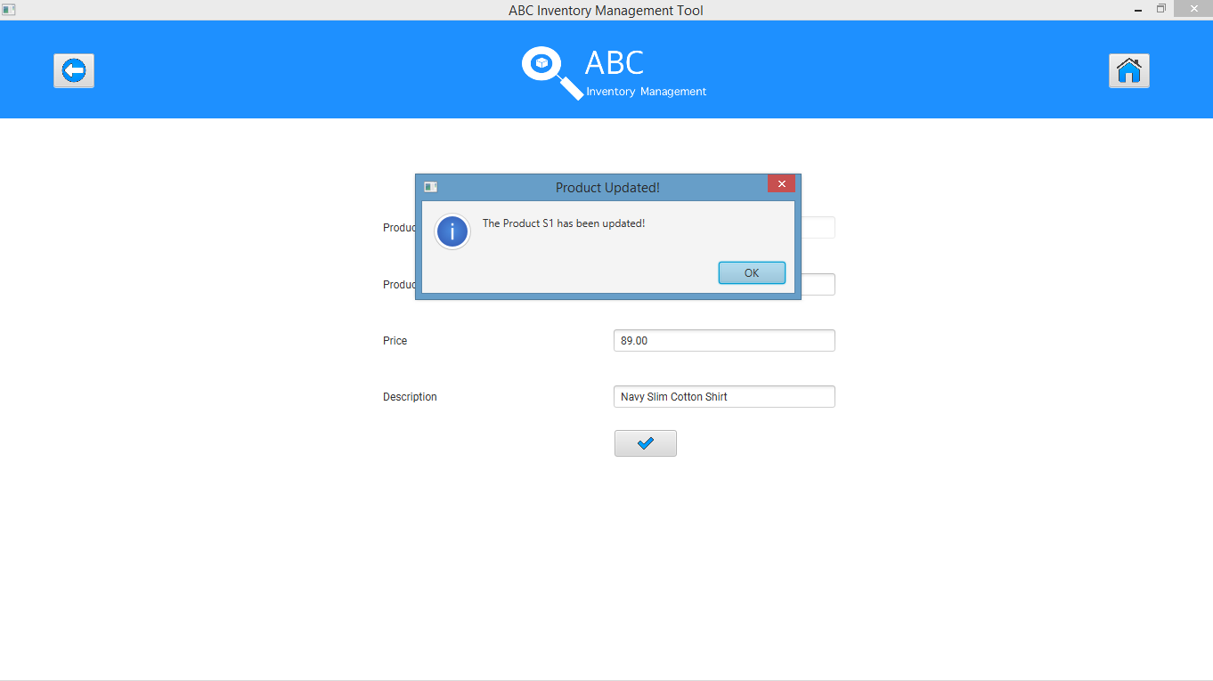

**Step 4**

System displays the ‘Manage Product’ page after the user clicks on ‘Ok’ in the dialog box.

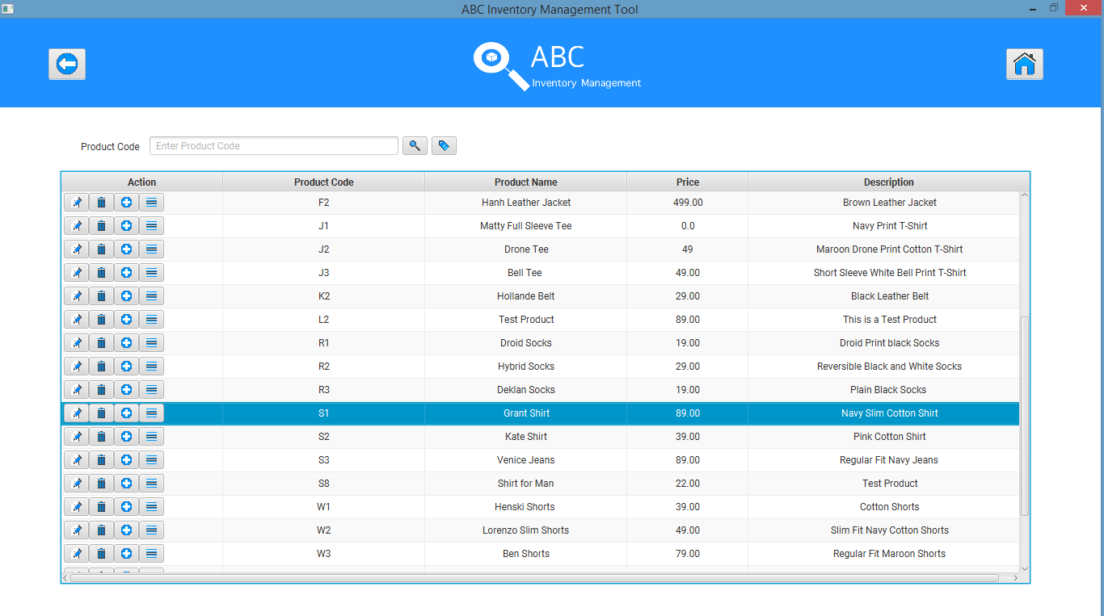

# UPT002- Skipping few data while updating details of a product that already exists

|  |  |  |  |  |  |
| --- | --- | --- | --- | --- | --- |
| **Test Name** | | Test skipping few data while updating details of a product that already exists (Test UPT002) | | | |
| **Use Case Tested** | | Manage Product | | | |
| **Test Description** | | This test tests how the system reacts when some data are left empty while updating details of a product | | | |
| **Pre-Conditions** | | Users need be logged in as a Warehouse Staff (Warehouse Staff Access) in the Manage Product page  Meta data to store Product details in the database must exist. | | | |
| **Post-Conditions** | | Appropriate error message is displayed. | | | |
| **Result (Pass/Fail/Warning/ Incomplete)** | | Pass | | | |
|  | **Test Step** | | **Expected Test Results** | **P** | **F** |
| 1. | Click on ‘Edit’ icon for the product whose details must be changed at the ‘Manage Product’ page. | | Update Product Page is displayed with all the details which are editable except for the product code. | P |  |
| 2. | Change required values but leave a few fields empty. | | System waits for the user to click on the ‘Confirm’ icon. | P |  |
| 3. | Click on the ‘Confirm’ icon. | | System displays an appropriate error message and prompts the user to enter required details. | P |  |
| 4. | Click on ‘Ok’ | | System highlights the fields that need to be entered. | P |  |

## Data Set 1

|  |  |
| --- | --- |
| **Data Set 1** | |
| **Fields** | **Values** |
| **Product Code** | L2 |
| **Product Name** | UPT002 TEST |
| **Price** |  |
| **Description** | TEST |

### Result Screenshots:

**Step 1**

Click on ‘Edit’ Icon for the product that needs to be updated.

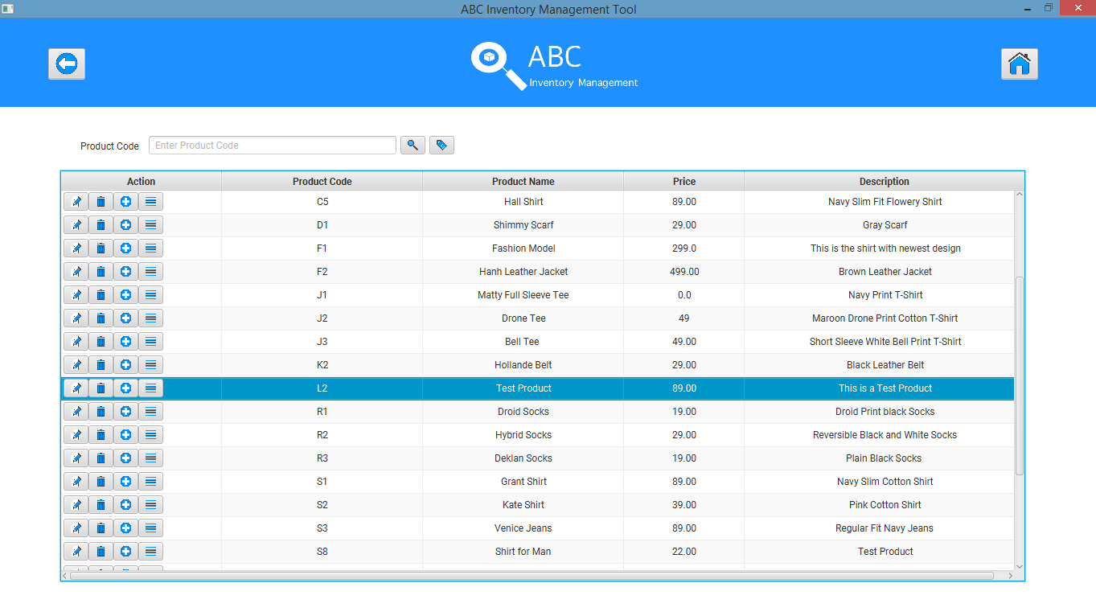

Update Product Page displaying all the details of the product that can be edited except for product code.

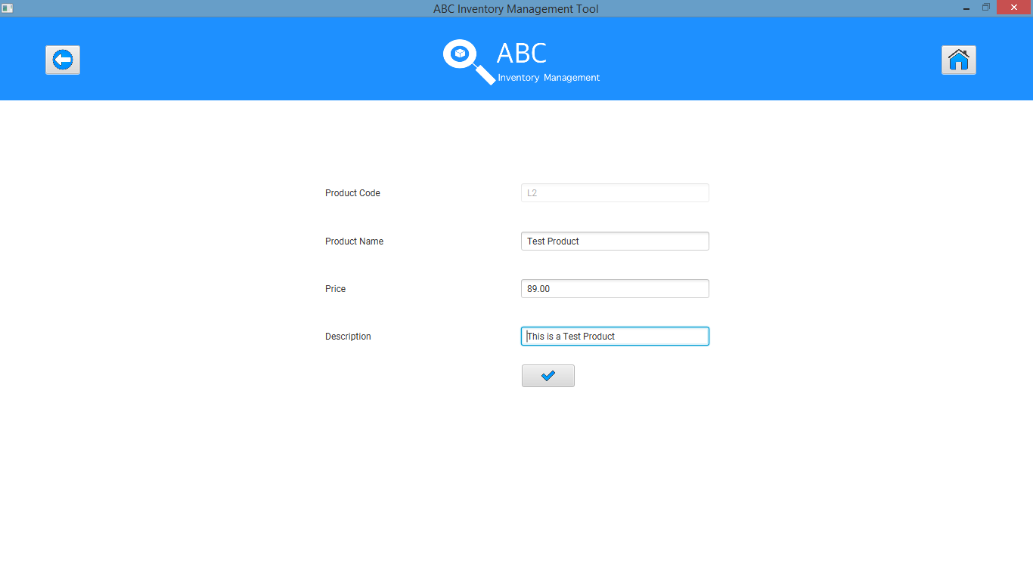

**Step 2**

Necessary updates are made. Price field is left empty.

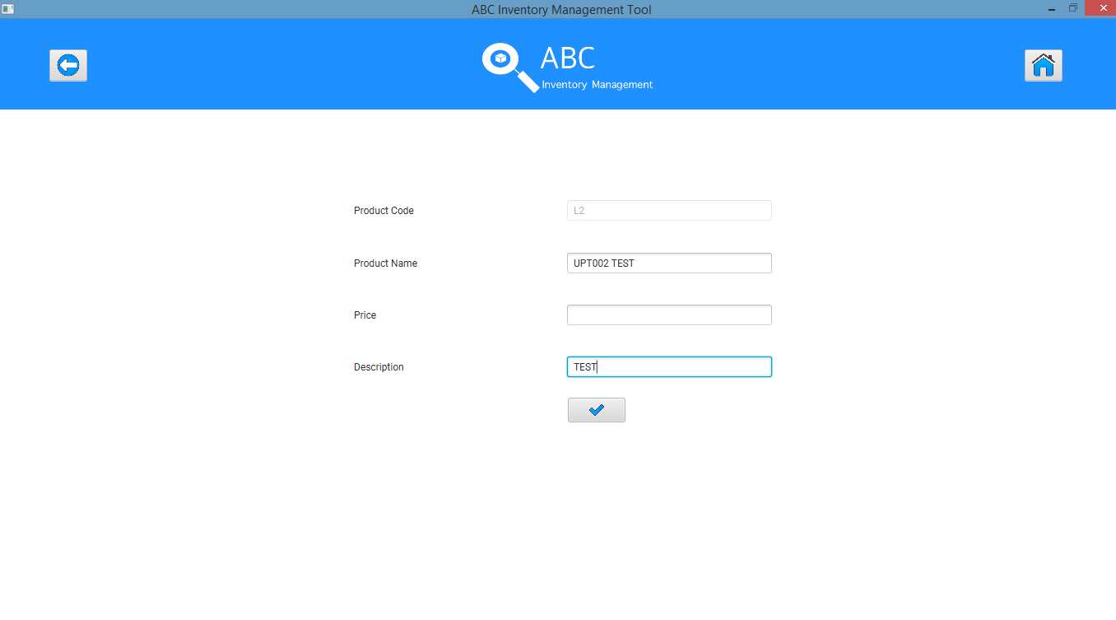

**Step 3**

After clicking on ‘Update’ Icon an appropriate message is displayed prompting user to enter all required field.

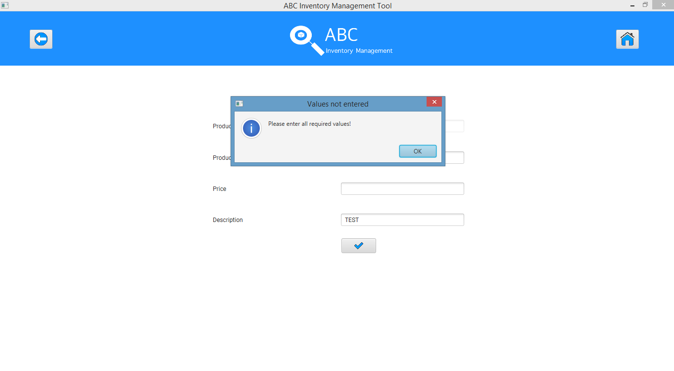

**Step 4**

After clicking ‘Ok’ the field that needs to be entered is highlighted.

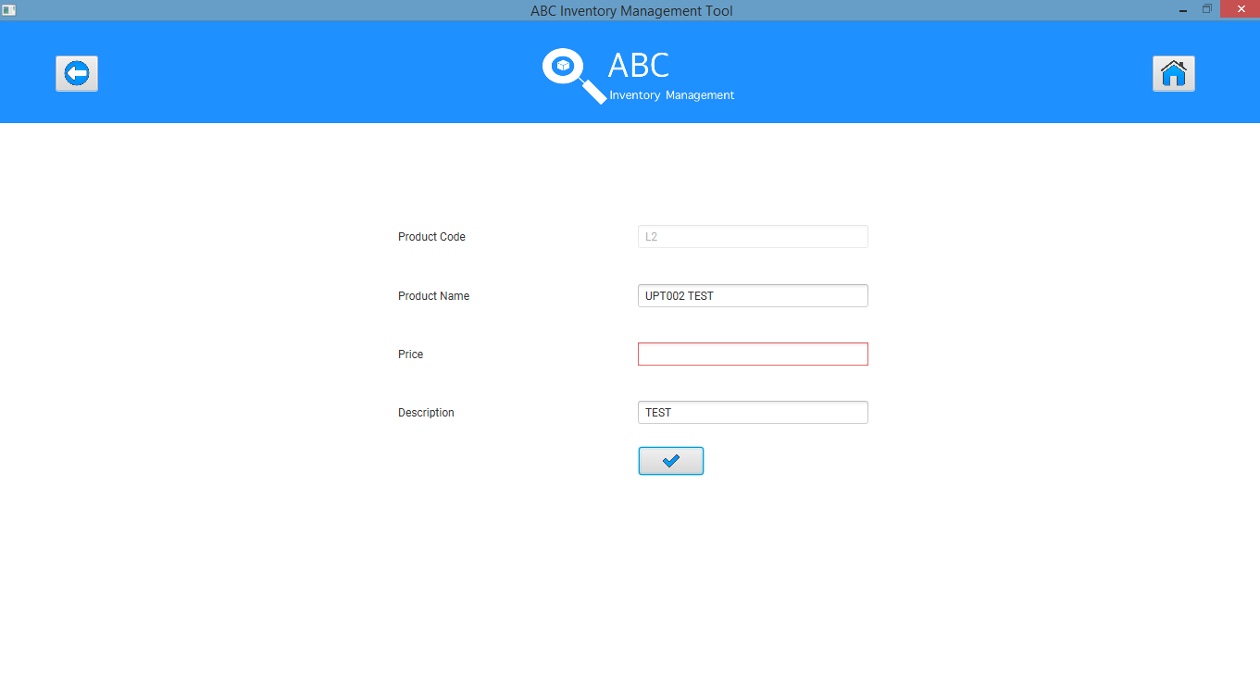

## Data Set 2

|  |  |
| --- | --- |
| **Data Set 2** | |
| **Fields** | **Values** |
| **Product Code** | L2 |
| **Product Name** |  |
| **Price** | 49.00 |
| **Description** |  |

### Result Screenshots:

**Step 1**

Click on ‘Edit’ Icon for the product that needs to be updated.

****Update Product Page displaying all the details of the product that can be edited except for product code.



**Step 2**

Necessary updates are made. Product Name and Description Field are left empty.

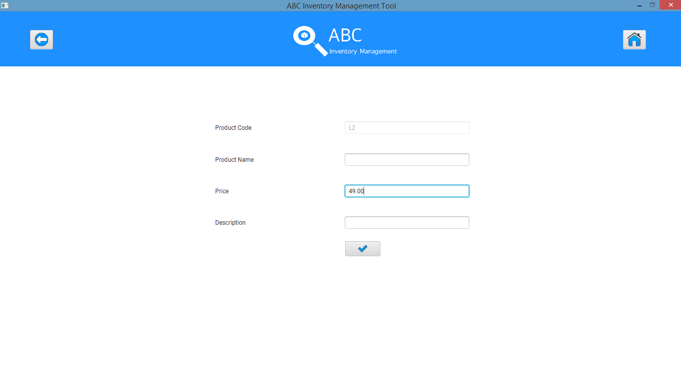

**Step 3**

After clicking on ‘Update’ Icon an appropriate message is displayed prompting user to enter all required field.

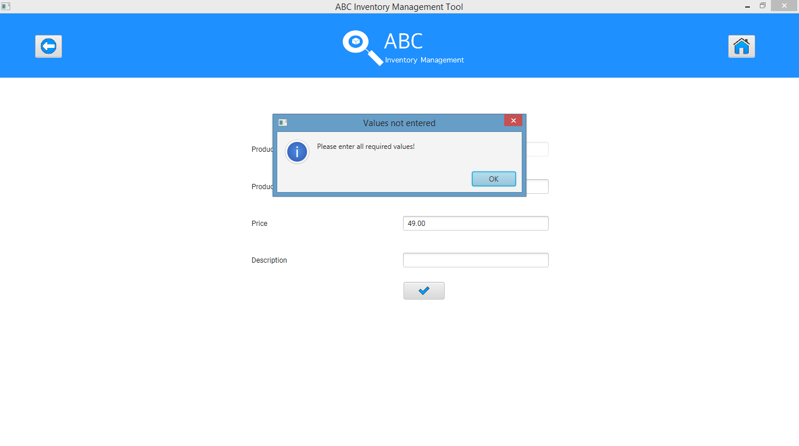

**Step 4**

After clicking ‘Ok’ the field that needs to be entered is highlighted.

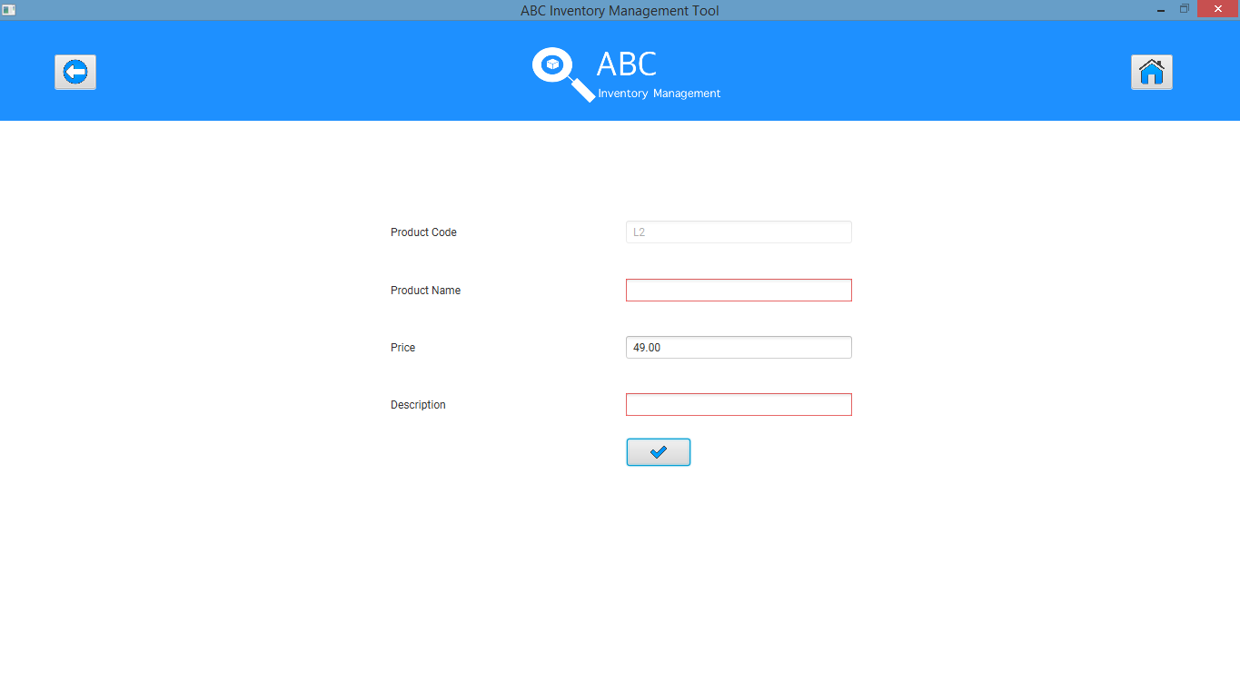

# UPT003- Entering invalid Price value while updating a Product

|  |  |  |  |  |  |
| --- | --- | --- | --- | --- | --- |
| **Test Name** | | Test entering invalid Price value while updating a Product (Test UPT003) | | | |
| **Use Case Tested** | | Manage Product | | | |
| **Test Description** | | This test tests how the system reacts when invalid price value is entered while updating details of a product | | | |
| **Pre-Conditions** | | Users need be logged in as a Warehouse Staff (Warehouse Staff Access) in the Manage Product page  Meta data to store Product details in the database must exist. | | | |
| **Post-Conditions** | | Appropriate error message is displayed. | | | |
| **Result (Pass/Fail/Warning/ Incomplete)** | | Pass | | | |
|  | **Test Step** | | **Expected Test Results** | **P** | **F** |
| 1. | Click on ‘Edit’ icon for the product whose details must be changed at the ‘Manage Product’ page. | | Update Product Page is displayed with all the details which are editable except for the product code. | P |  |
| 2. | Change required values but enter an invalid price value. | | System waits for the user to click on the ‘Confirm’ icon. | P |  |
| 3. | Click on the ‘Confirm’ icon. | | System displays an appropriate error message and prompts the user to enter a valid price value. | P |  |
| 4. | Click on ‘Ok’ | | System clears the price field and highlights it in red. | P |  |

## Data Set 1

|  |  |
| --- | --- |
| **Data Set 1** | |
| **Fields** | **Values** |
| **Product Code** | L2 |
| **Product Name** | TEST |
| **Price** | ABC (Non-numeral value) |
| **Description** | TEST |

### Result Screenshots:

**Step 1**

Click on ‘Edit’ Icon for the product that needs to be updated.



Update Product Page displaying all the details of the product that can be edited except for product code.



**Step 2**

Make necessary changes but enter ‘ABC (non-numeral)’ price value and click on ‘Update’ icon

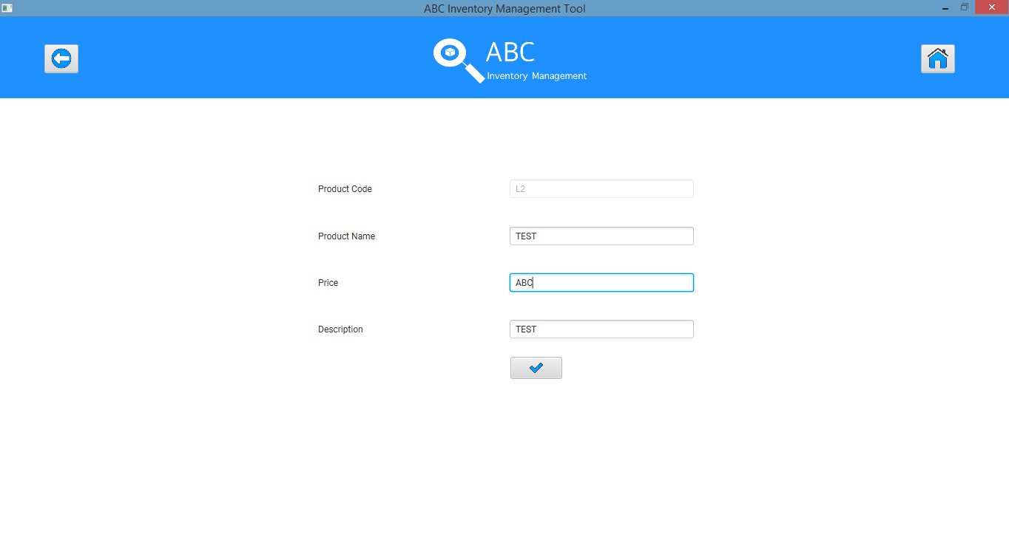

**Step 3**

System displays an appropriate message prompting user to enter a valid price value.

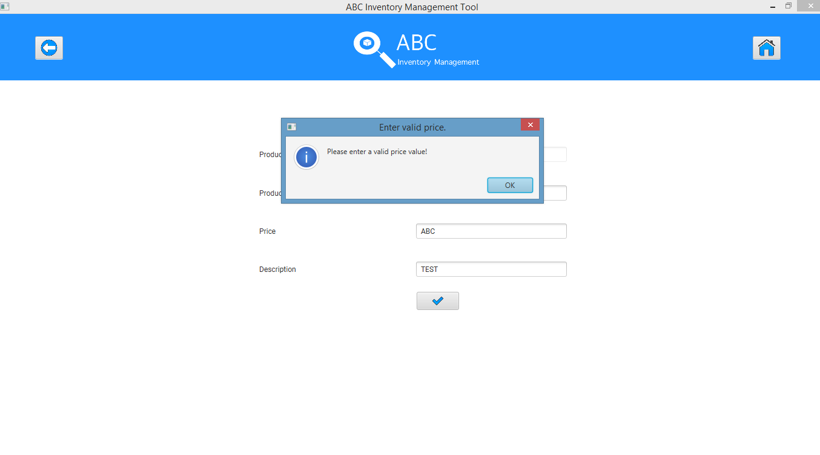

**Step 4**

After user clicks on ‘Ok’, the system clears the price field and highlights it in red.

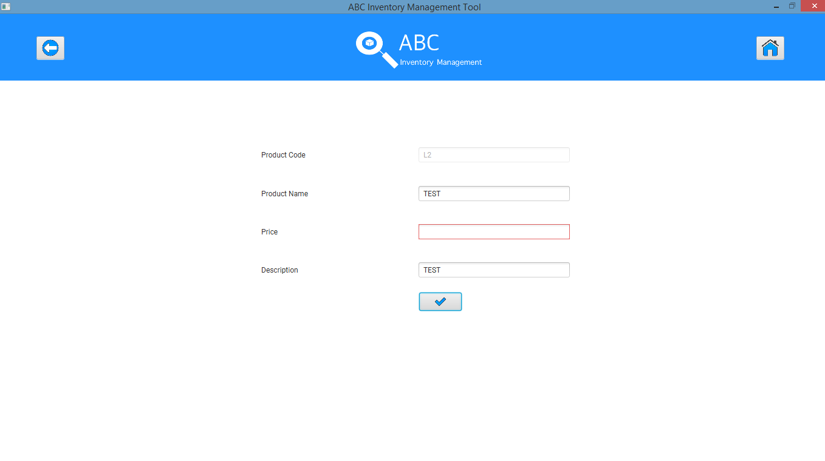

## Data Set 2

|  |  |
| --- | --- |
| **Data Set 2** | |
| **Fields** | **Values** |
| **Product Code** | L2 |
| **Product Name** | TEST |
| **Price** | -99.00 (Negative value) |
| **Description** | TEST |

### Result Screenshots:

**Step 1**

Click on ‘Edit’ Icon for the product that needs to be updated.



Update Product Page displaying all the details of the product that can be edited except for product code.



**Step 2**

Make necessary changes but enter ‘-99.00 (Negative value)’ price value and click on ‘Update’ icon

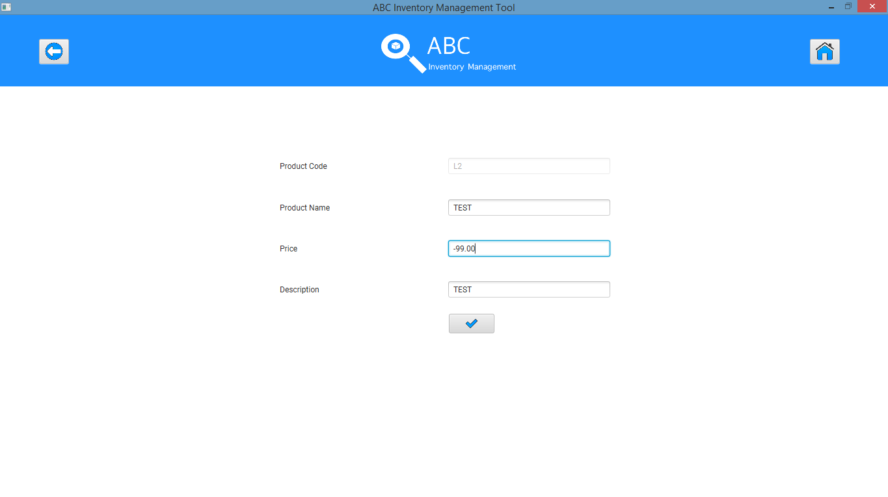

**Step 3**

System displays an appropriate message prompting user to enter a valid price value.

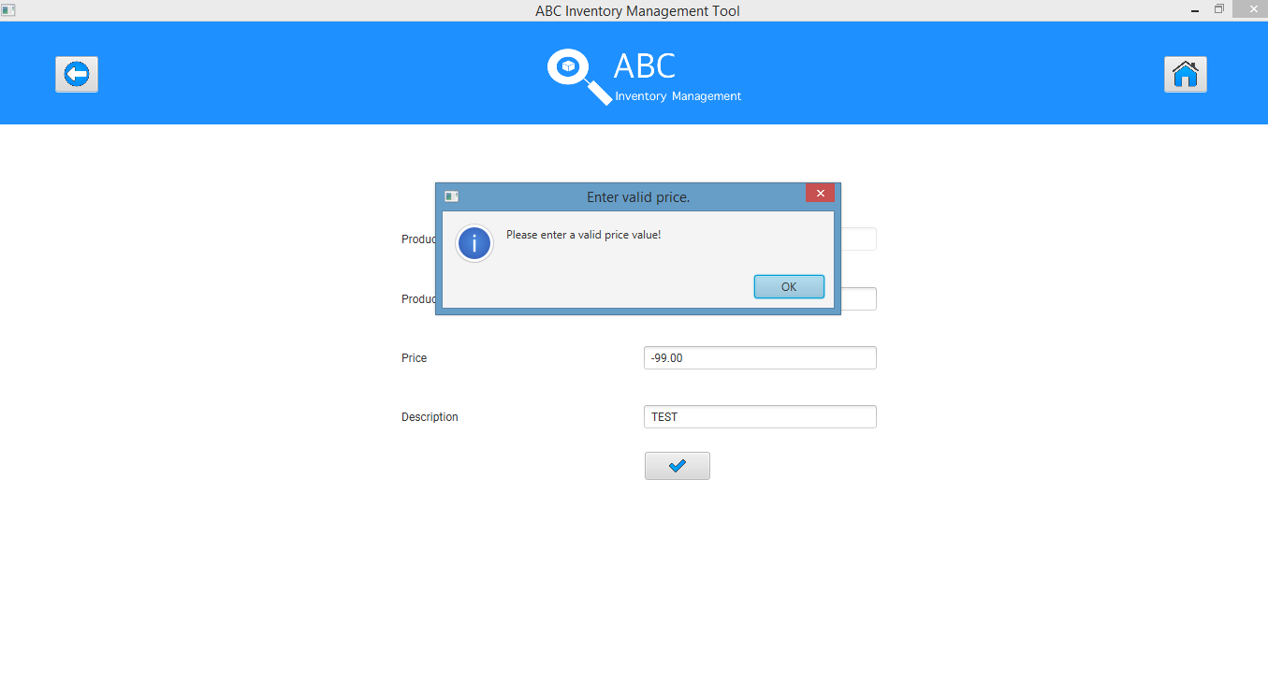

**Step 4**

After user clicks on ‘Ok’, the system clears the price field and highlights it in red.

